Case Report

R J M E

**Romanian Journal of Morphology & Embryology**

[**http://www.rjme.ro/**](http://www.rjme.ro/)

**A rare case of mitochondriopathy with autosomal dominant progressive external ophthalmoplegia diagnosed through skeletal muscle biopsy**

ALEXANDRA EUGENIA BASTIAN1), GHEORGHIŢĂ JUGULETE2), EMILIA MANOLE3), LUMINIŢA ALEXANDRA OPRIŞAN4)

1)Department of Pathology, Faculty of Dental Medicine, “Carol Davila” University of Medicine and Pharmacy, Bucharest, Romania; Department of Pathology, “Colentina” Clinical Hospital, Bucharest, Romania

2)Department of Infectious Diseases, “Carol Davila” University of Medicine and Pharmacy, Bucharest, Romania; Clinical Section IX – Pediatrics, “Prof. Dr. Matei Balş” National Institute for Infectious Diseases, Bucharest, Romania

3)Department of Pathology, “Colentina” Research Center, “Colentina” Clinical Hospital, Bucharest, Romania; Department of Molecular Biology, “Victor Babeş” National Institute for Research and Development in Pathology and Biomedical Sciences, Bucharest, Romania

4)Department of Neurology, “Colentina” Clinical Hospital, Bucharest, Romania; Department of Neurology, “Carol Davila” University of Medicine and Pharmacy, Bucharest, Romania

# Abstract

Mitochondriopathies are a heterogeneous group of genetic diseases of all ages, with a very diverse clinical presentation related to genetic heteroplasmy. The clinical symptoms display a large variability and generally, the more severe phenotypes have an early onset, even from the neonatal period, while milder ones are manifested later in the adulthood. Most publications have already demonstrated deletions or point mutations in mitochondrial deoxyribonucleic acid (DNA), but in recent years, the field of investigation has expanded to syndromes caused by mutations in the nuclear DNA (nDNA), with a Mendelian inheritance. We present the case of a male patient with a mitochondriopathy with phenotype of chronic progressive external ophthalmoplegia (PEO), due to an autosomal dominant mutation in nDNA, in the DNA polymerase subunit gamma (*POLG*) gene, the pathogenic variant c.2864A>G (p.Tyr955Cys), morphologically investigated and diagnosed using a skeletal muscle biopsy. The aim of this presentation is to emphasize the diagnostic value of the muscle biopsy both in cases of clinical suspicion and in more challenging cases of mitochondrial diseases with atypical or unusual features. Although genetic testing may be the initial test of choice in cases with suggestive clinical presentation, muscle biopsy is an alternative diagnostic aid with high value even in our molecular era. We present pathological and ultrastructural data to confirm the diagnosis.

***Keywords*:** mitochondriopathy, progressive external ophthalmoplegia, nuclear DNA mutation, electron microscopy.

#  Introduction

Mitochondriopathies are a heterogeneous group of genetic diseases of children and adults, with a very diverse clinical presentation, involving a single organ or, even more frequently, multisystemic, making the diagnostic workup a real challenge. Their worldwide prevalence is estimated to range between 1/5000 and 1/8500, with many undiagnosed cases worldwide. This group of diseases is the result of dysfunctions of the mitochondrial respiratory chain [1]. The clinical symptoms have a large variability and generally, the more severe phenotypes have an early onset, even from the neonatal period, while milder ones manifest later in the adulthood.

The most important types of mitochondriopathies are mitochondrial encephalomyopathy, lactic acidosis, and stroke-like episodes (MELAS), Leigh syndrome (subacute necrotizing encephalomyelopathy), myoclonic epilepsy with ragged-red fibers (MERRF), autosomal dominant or autosomal recessive–progressive external ophthalmoplegia (ad/ar–PEO), Alpers disease (epilepsy with liver failure), sensory ataxic neuropathy, dysarthria and ophthalmoparesis (SANDO), Leber hereditary optic neuropathy (LHON),

neuropathy, ataxia, and *retinitis pigmentos*a (NARP), and Kearns–Sayre syndrome (KSS).

The mitochondrion is the location of energy production in the cell (through oxidative phosphorylation). This process has dual genetic control as it is regulated by genes in both mitochondrial deoxyribonucleic acid (mtDNA) and nuclear DNA (nDNA), thus, mitochondrial myopathies are produced by mutations in the nuclear or mitochondrial genome. Mitochondria are ubiquitous in all tissues except for red blood cells and this is the explanation why clinical features manifest typically in tissues with high-energy requirements like brain, skeletal muscles, myocardium or endocrine organs. Over 1500 mitochondrial proteins and 37 mitochondrial genes are currently known.

Most publications have already demonstrated deletions or point mutations in mtDNA, but in recent years, the field of investigation has expanded to syndromes caused by mutations in the nDNA, with a Mendelian inheritance [2]. The first mutations in nDNA, associated with secondary multiple deletions in mtDNA were described in 1999 by Nishino *et al.* [3]. They caused an autosomal recessive disease, mitochondrial neurogastrointestinal encephalo- myopathy (MNGIE). It was followed by the discovery of

ISSN (print) 1220–0522 ISSN (online) 2066–8279

other nuclear genes involved in mitochondrial pathology, like PEO with Mendelian inheritance. Most nDNA mutations are autosomal recessive, but there are also few autosomal dominant, and two mutations are linked to chromosome X [2].

PEO, chronic PEO (CPEO) or autosomal dominant PEO1 (adPEO1) mitochondriopathy is a mitochondrial disease with CPEO, caused by an autosomal dominant mutation in nDNA, DNA polymerase subunit gamma (*POLG*) gene, on chromosome 15q25, with a Mendelian transmission. This gene encodes for the catalytic subunit of the mtDNA polymerase (pol-*γ*) and the disorders produced by a mutation in *POLG* gene may be inherited both in a recessive and a dominant way [4, 5]. Defects in pol-*γ* lead to multiple mtDNA deletions. Less commonly, similar mutations may cause mtDNA depletion [6]. The precise molecular mechanisms underlying such variability have not yet been deciphered [7].

PEO is clinically characterized by onset between 18 and 40 years old, ptosis and weakening of the external eye muscles, blepharoptosis and ophthalmoparesis. Weakness and wasting of proximal limb muscles and exercise intolerance are also associated with PEO.

We present a rare case of adult onset PEO1 due to an autosomal dominant mutation in nDNA encoding for *POLG* on chromosome 15q25, with a definitive molecular genetic confirmation achieved after a histopathological recognition of the mitochondrial abnormalities. Our case demonstrates that a muscle biopsy with optimal processing of the tissue may be a key diagnostic tool that can establish a fast and accurate diagnosis and direct molecular genetic testing in these diseases with incredible phenotypic and genetic diversity.

#  Case presentation

The patient is a 49-year-old man (PN) from urban area, with higher education and professional activity, with unremarkable past medical history, who presented three years ago to the Hospital (Department of Neurology, “Colentina” Clinical Hospital, Bucharest, Romania, Medical Record No. 104553/2015) for a specialized medical consultation because of progressive bilateral eye weakness and fatigue with drooped eyelids, without diurnal variation of the symptoms and slight difficulty in swallowing (Figure 1).

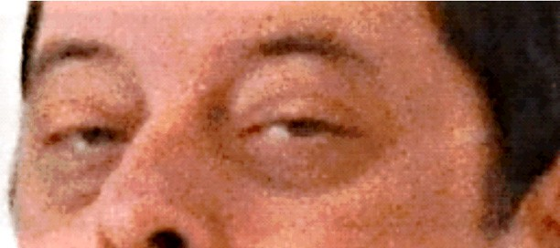

**Figure 1 – *Ophthalmoplegia of the patient, in 2014: progressive bilateral eye weakness and fatigue with drooped eyelids.***

His 63-year-old brother and 88-year-old mother have no similar problems. His father died when the patient was a small child, but did not show any sign of neuromuscular disease throughout his life. Nobody else in the family ever experienced similar symptoms. Both ophthalmoplegia and dysphagia have evolved over time (Figure 2). Thinking retrospectively and analyzing photographs from his personal

archive, the patient realized that the symptoms actually started many years in advance, probably around the age of 35, but remained unnoticed. The patient also had a mild and very slowly progressive proximal limb weakness.

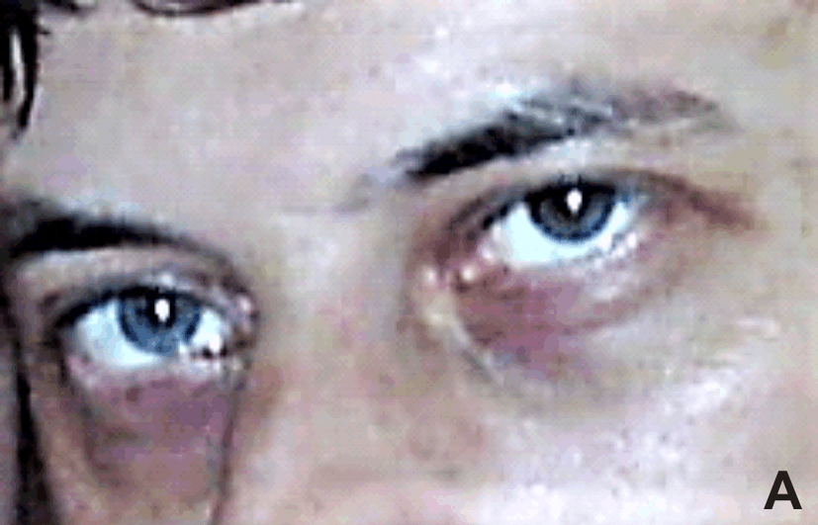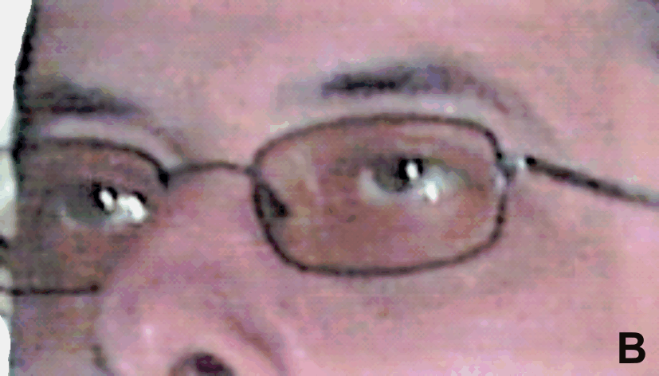

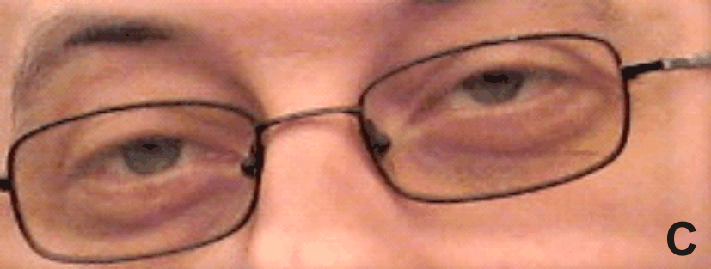

**Figure 2 – *Evolution of ophthalmoplegia over time – years 2005 (a), 2007 (b), and 2011 (c).***

The first clinical diagnosis suspected by the ophthalmologist and then neurologist was myasthenia gravis, but anti-acetylcholine receptor and anti-muscle- specific kinase (MuSK) receptor antibody levels were normal.

Other investigations like computed tomography scan, spirometry, electromyography and Doppler ultrasound were also performed at that time, without conclusive results. Serum creatine kinase level was mildly elevated. After injection of Pyridostigmine (Mestinon), the eyelid lifting effect was insignificant, however he received corticosteroid treatment and Neostigmine for nine months, without any clinical improvement. After discontinuing treatment for several days on his own initiative, the patient did not experienced any worsening of the symptoms, however he continued the prescribed treatment with Neostigmine and intermittent corticotherapy. Persistence of symptoms urged him to continue the investigations. Another consultation at the Department of Neurology, University Emergency Hospital, Bucharest, raised the clinical suspicion of oculopharyngeal muscular dystrophy, based on the association of ptosis with dysphagia and a muscular biopsy was recommended to confirm the clinical diagnosis. It is important to note that a possible diagnosis of mitochondrial disease was never clinically suspected before performing the muscle biopsy.

An open muscle biopsy from the left deltoid muscle under local anesthesia using Lidocaine subcutaneous injection was performed at “Colentina” Clinical Hospital, Bucharest, after informed consent of the patient for the procedure was obtained, the muscle tissue processing being accomplished in the Department of Pathology of the same Hospital.

A skeletal muscle tissue fragment was snap frozen in liquid nitrogen cooled isopentane. Following the orientation of the muscle, transversal 8 μm thickness cryosections were obtained. They were processed and stained for examination with histology and histochemistry techniques [Hematoxylin–Eosin (HE), van Gieson, modified Gömöri trichrome (GT), Sudan BB, Periodic Acid–Schiff (PAS)] and enzyme histochemical preparation for reduced nicotinamide adenine dinucleotide tetrazolium reductase (NADH-TR), succinate dehydrogenase (SDH), lactate dehydrogenase (LDH), adenosine triphosphatase (ATPase) at pH 9.4, 4.63 and 4.35. After muscle sections examination in light microscopy, a cytochrome oxidase IV investigation using the cytochrome c oxidase (COX) or complex IV reaction and a combined COX–SDH staining were ordered, due to the presence of ragged-red fibers on GT and HE stainings.

Another small longitudinal of 0.5 mm length fragment

of muscle tissue was fixed in buffered 2.5% glutaraldehyde, embedded in Epon 812 resin after osmication; semithin and ultrathin sections were obtained and contrasted with uranyl acetate and lead citrate for ultrastructural exami- nation.

A separate piece of muscle tissue was formalin-fixed, paraffin-embedded, and the sections were stained with HE. On examination in light microscopy, the striated muscle tissue fragment had a well-preserved overall architecture, but an obvious fiber size variation, with scattered elongated, isolated atrophic fibers (Figure 3). Very rare, more intensely

colored fibers or fibers with a clear external rim were noticed on HE staining (Figure 4), with a granular aspect and a fine reddish border/red rim and irregular sarcoplasm on GT staining, giving a “ragged-red” appearance and with more intense reaction on oxidative enzyme stainings (Figure 5). The “ragged-red“ fibers were hyper-reactive and stained darkly with SDH (Figure 6), the most sensitive staining for detecting mitochondrial proliferation, appearing as “ragged-blue“ fibers. These fibers were COX-negative. A dominance of type I muscle fibers and small clusters of type II fibers had also been observed (Figure 7). Increased focal punctate lipid inclusions within some of the myofibers were highlighted by Sudan BB staining (Figure 8), and PAS staining was more prominent in several fibers (Figure 9). The COX reaction showed obvious scattered negative muscle fibers lacking COX activity (Figure 10), staining blue with the combined COX–SDH staining, a clearly pathological aspect as in normal biopsies all fibers have staining for COX. These findings were diagnostic of mitochondrial myopathy and ultrastructural examination was further performed. The clinical suspicion of oculopharyngeal muscular dystrophy based on the association of ptosis with dysphagia could be ruled out by the absence of rimmed cytoplasmic vacuoles or other morphological aspects described in this disease and identification of ragged-red/ragged-blue fibers highly suggestive for a mitochondrial disease. The remaining muscle tissue was stored at -800C in a deep freezer.

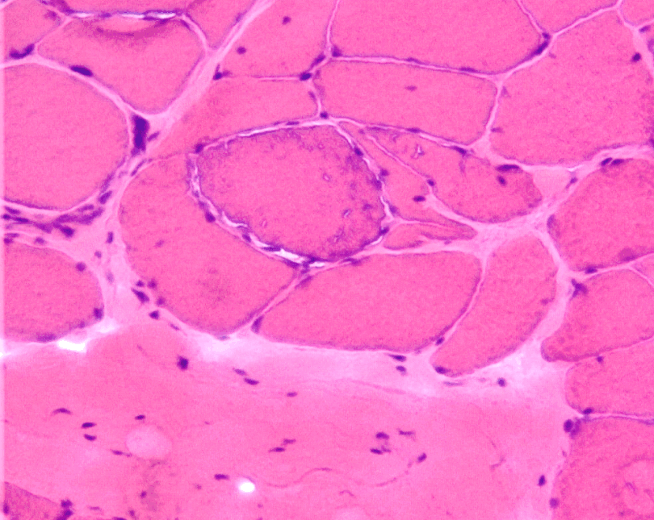 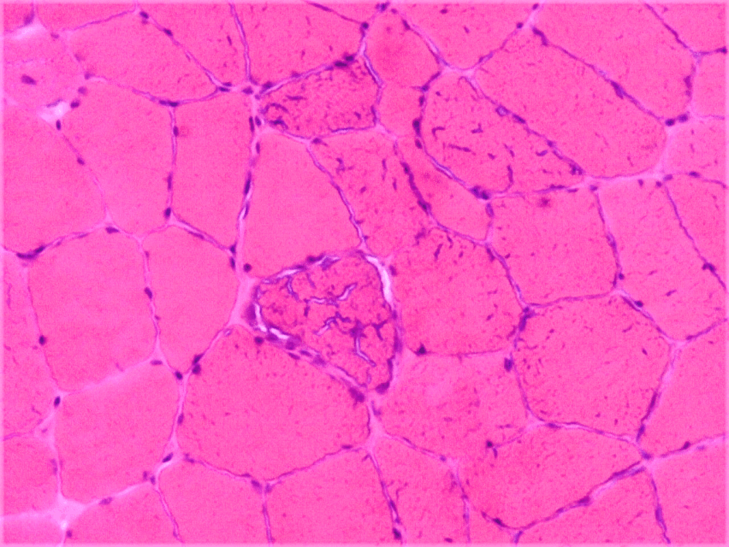 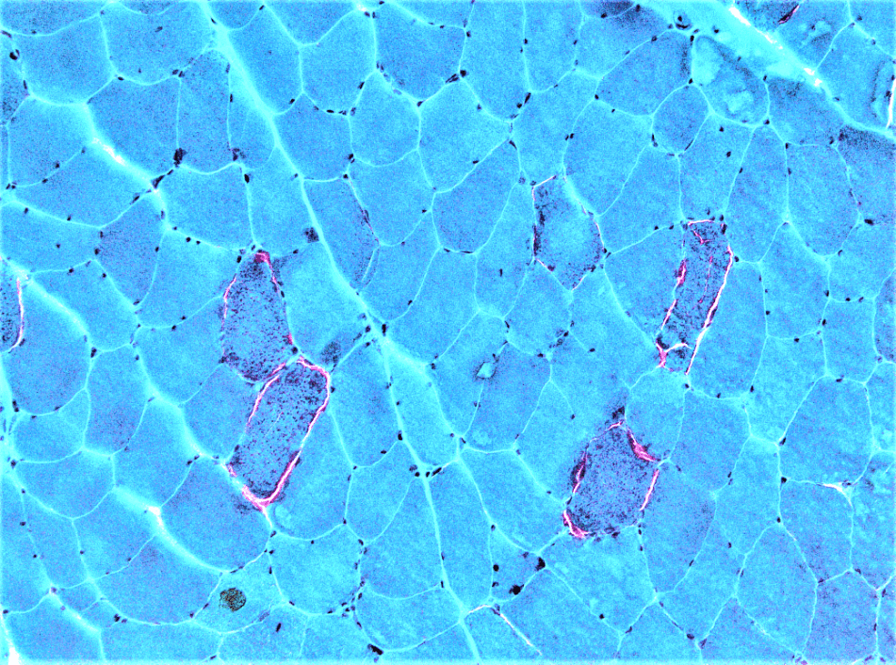

**Figure 3 – *Muscle cryosections: well preserved architecture with fiber size variation, isolated atrophic fibers. HE staining, 100×.***

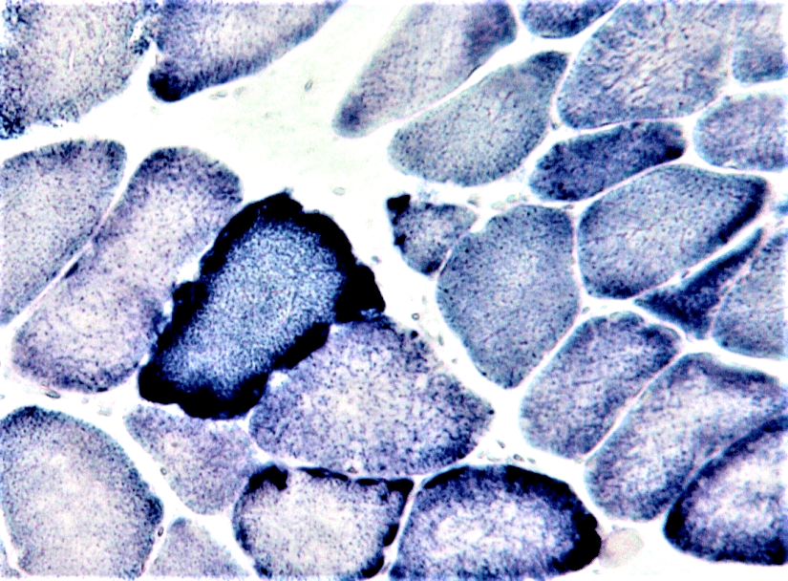

**Figure 6 – *Muscle cryosections: the “ragged-blue” fibers, hyper-reactive for SDH. SDH staining, 100×. SDH: Succinate dehydrogenase.***

**Figure 4 – *Muscle cryosections: very rare, more intensely colored fibers, with a granular aspect. HE staining, 100×.***

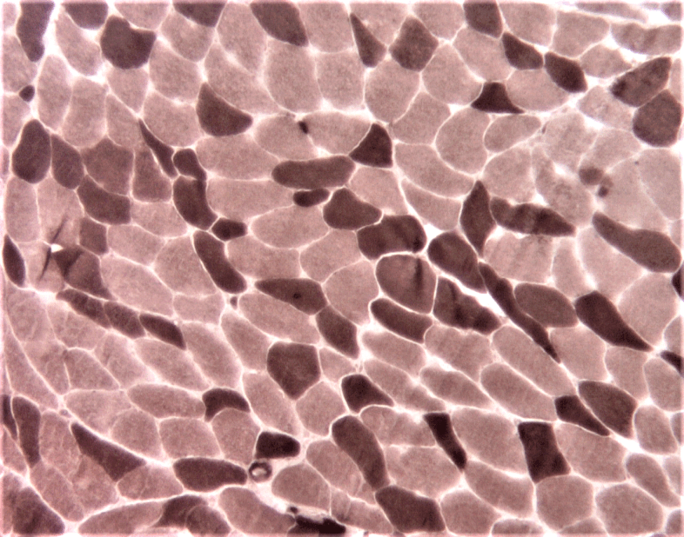

**Figure 7 – *Muscle cryosections: a dominance of type I muscle fibers (stained light) and small clusters of type II fibers (stained dark). ATPase staining at pH 9.4, 40×. ATPase: Adenosine triphosphatase.***

**Figure 5 – *Muscle cryosections: some fibers with a granular aspect and a fine reddish border on GT staining, giving a “ragged-red” appearance (100×).***

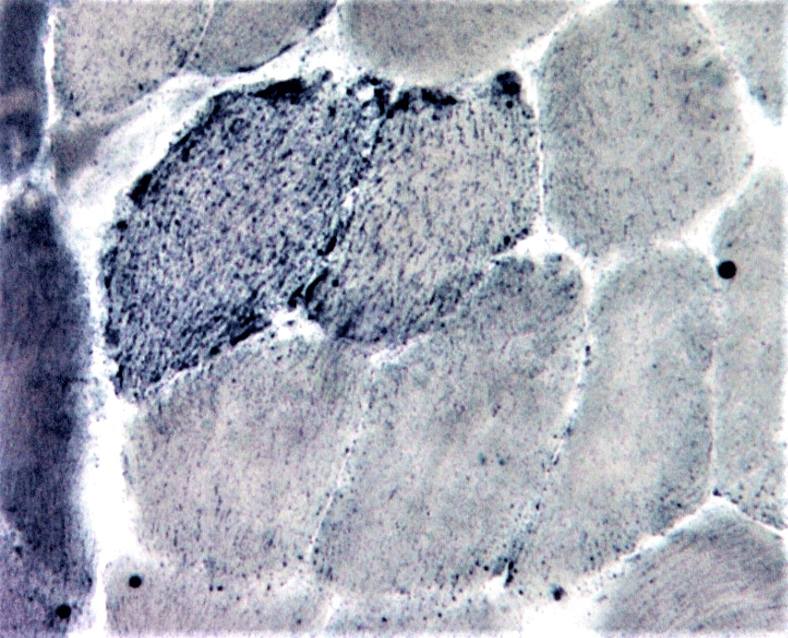

**Figure 8 – *Muscle cryosections: increased focal punctate lipid within myofibers, highlighted by Sudan BB. Sudan BB staining, 100×.***

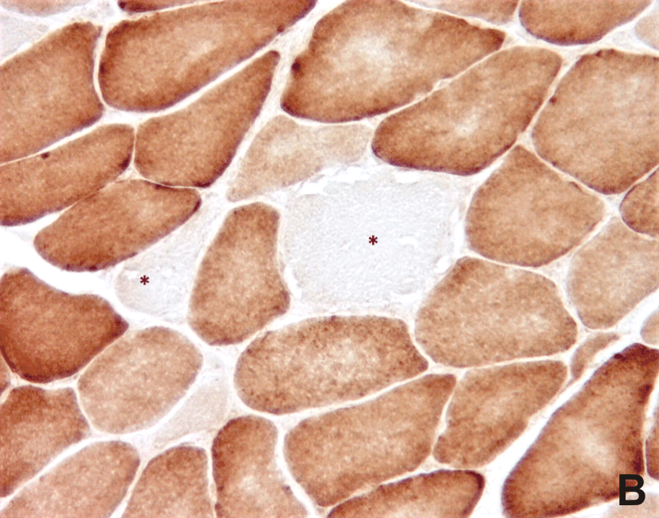

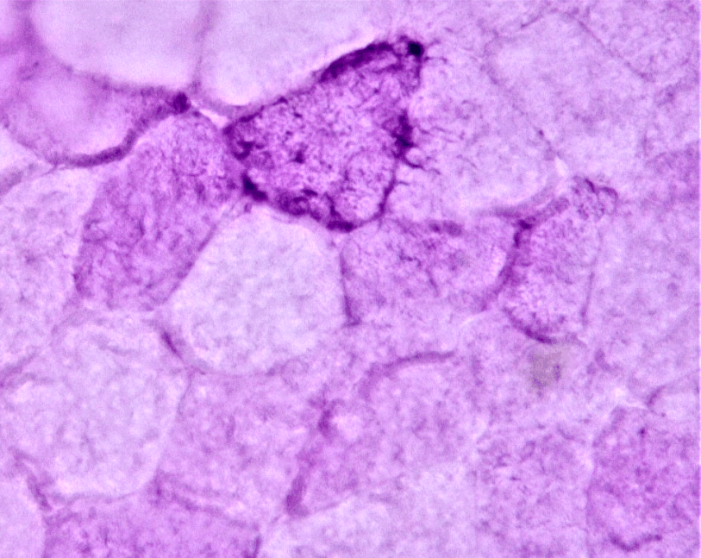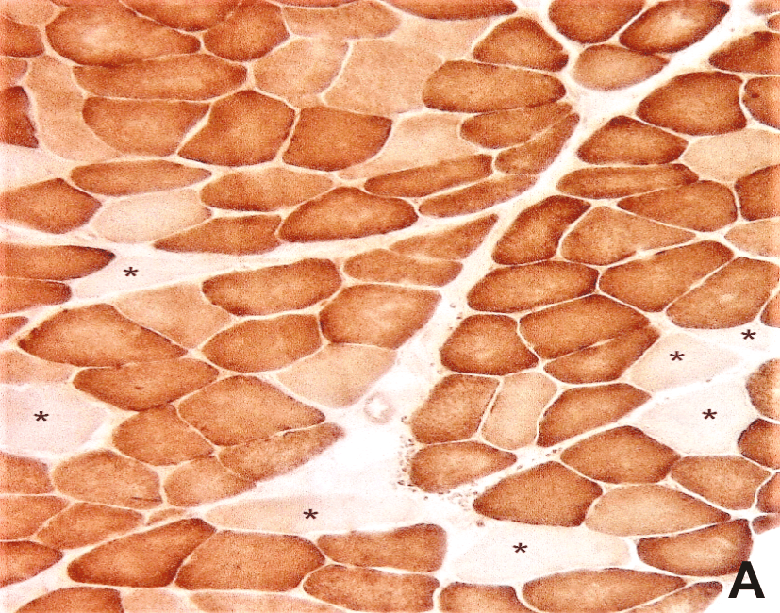

**Figure 9 – *Muscle cryosections: some PAS more prominent fibers. PAS staining, 100×.***

**Figure 10 – *Muscle cryosections: the COX reaction revealing several negative muscle fibers lacking COX activity (asterisk): (A) 40×; (B) 100×. COX: Cytochrome c oxidase.***

Routine transmission electron microscopy (TEM) was performed on ultrathin sections stained with uranyl acetate and lead citrate. TEM examination showed an increase in the number and size of the mitochondria with sub- sarcolemmal and perinuclear accumulation of abnormal mitochondria (Figure 11), some of them with abnormal

concentric cristae (Figure 12) and some others with round electron-dense bodies inside and circular cristae (Figure 13). Concentric cristae or “onion-like” mitochondria, observed in patient’s muscle samples are named also “tubular parallel cristae” or “concentric laminated bodies”.

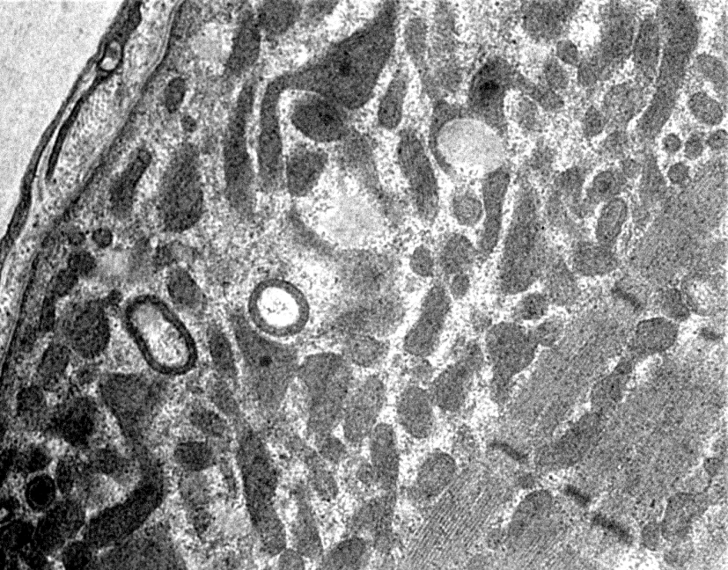 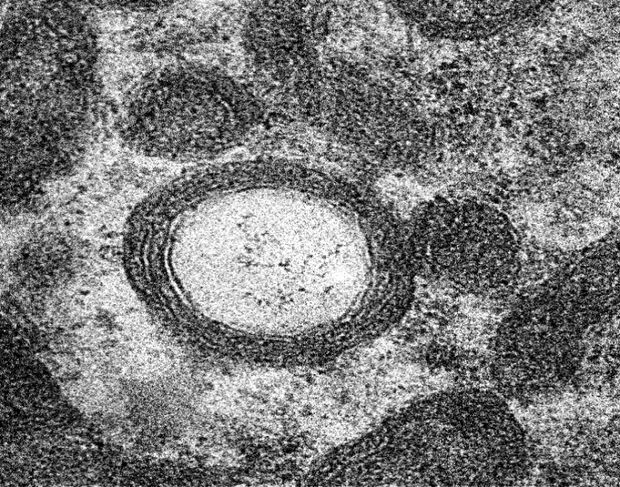 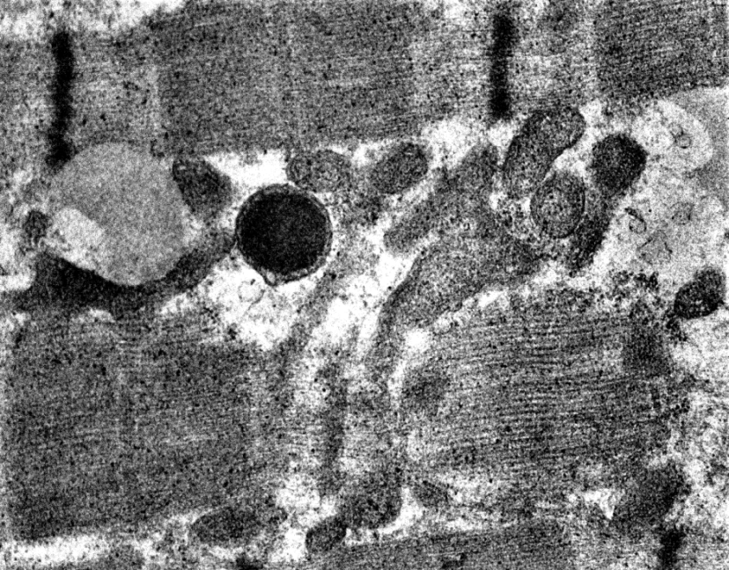

**Figure 11 – *Electron microscopy: subsarcolemmal accumulation of mitochondria; some mitochondria with abnormal concentric cristae (6500×).***

**Figure 12 – *Electron microscopy: concentric cristae or “onion-like” mitochondria (20 000×).***

**Figure 13 – *Electron microscopy: some mitochondria with round electron-dense bodies inside and circular cristae (11 500×).***

Receiving a pathological diagnosis, which refers to a genetic progressive disease, the patient became very anxious and concerned about the risk that his single 14-year-old healthy son might eventually inherit the disease. For genetic confirmation and counseling, a DNA sample extracted from the patient’s blood was prepared for genetic analysis in May 2016 and was sent to Belgium, at the Center for Medical Genetics, UZ Brussel.

The first genetic tests addressed to the mitochondrial genome and did not identify any abnormality.

At this stage of the diagnostic approach, the genetic testing has been extended in August 2016 to nDNA analysis using the panel for mitochondrial diseases and identified a mutation in the *POLG* gene, the pathogenic variant c.2864A>G (p.Tyr955Cys) in January 2017. Sequencing analysis with massive parallel sequencing of the coding exons and part of the flanking introns of the genes included in mitochondrial disease gene panel (target capture Roche) was performed. This mutation has been associated in literature with dominant PEO and PEO with Parkinson. Using genetic testing, the clinical suspicion of a mito- chondrial disease was confirmed, with the identification of an autosomal dominant gene defect in *POLG*. All siblings and children of this patient have an estimated risk of 50% to be affected. Genetic counseling of the patient is now essential.

Our patient currently performs normal physical and professional activity while scheduling surgery to correct ptosis and for the time, being decided to postpone his son’s genetic testing. Studying the ophthalmological literature, the patient also designed and made himself special crutches attached to his glasses to keep the eyelids elevated.

#  Discussions

Clinical diagnosis of mitochondrial disorders is com- plicated by various phenotypes that lead to dysfunctions of almost any organ [8].

PEO is a common manifestation of a mitochondrial disease with onset in adulthood and is usually associated with either primary mtDNA mutations or secondary mtDNA defects caused by mutations in nDNA (with effect in disrupting mtDNA maintenance). Many patients do not have a genetic diagnosis but have multiple deletions of mtDNA in skeletal muscle. Extremely rare cases of PEO without ptosis or late onset eyelid ptosis in the disease course were also described. Both autosomal dominant and autosomal recessive inheritance can occur; autosomal recessive inheritance is usually more severe [9].

The most common clinical features in PEO1 are weakness of the external eye muscles and exercise

intolerance, with rare and variable additional symptoms including cataract, sensory axonal neuropathy, ataxia, hearing loss, depression, hypogonadism, and parkinsonism. Fortunately, none of these possible additional signs have been observed in our patient. Besides the eye symptoms, our patient had progressive dysphagia with a gradual degradation of swallowing. It is important to take into account the presence of all gastrointestinal manifestations in mitochondrial diseases diagnosis (*e.g.*, the motility disorders). Dysphagia can be caused by either central nervous system (CNS) involvement, peripheral nerves, or involvement of smooth muscle cells. This phenomenon is common in mitochondrial disease [10]. One of the most important measures in treating dysphagia in mitochondrial diseases is avoidance of toxic drugs for mitochondrion, such as Dichloroacetate, Linezolid, Chloramphenicol, aminoglycosides, Valproic acid, Carbamazepine, Pheno- barbital, statins or nucleoside reverse transcriptase (NRT) inhibitors, aspects which are not well known or taken into account by many physicians [11].

A genetic diagnosis can lead to the avoidance of muscle biopsy, but many cases, with or without a genetic diagnosis, require a muscular biopsy for confirmation, especially the cases of unknown mutations. Skeletal muscle is considered to be the best tissue to confirm a mito- chondrial myopathy using histochemical and biochemical tests that can be done on tissue: COX (complex IV) activity and SDH (complex II) activity [12]. Some authors demonstrated that different mitochondrial syndromes have contrasting histochemical features, with ragged-red fibers and COX-negative fibers being more prevalent in PEO than in MERRF syndrome or MELAS [13]. Negative COX muscle fibers may suggest a mitochondrial genetic problem that requires further investigations of specific gene panels, exosome sequencing or whole genome sequencing [14].

A main pathological challenge is to perform the muscle biopsy and process the tissue using standardized protocols to preserve not only morphology of mito- chondria, but also the enzymatic activity and genetic content of the tissue to allow further specific investiga- tions, like mitochondrial respiratory chain studies, essential in these diseases. This requirement can be achieved only through a multidisciplinary approach, including surgeon, clinician and pathologist. Actual protocols require a small fragment of fresh muscle collected in ribonuclease (RNase) free tubes to be snap frozen in liquid nitrogen for biochemistry and genetic testing [15].

Not only processing, but also interpretation of morpho- logical findings in mitochondriopathies is difficult because the histological and histochemical features are not entirely specific. Separating primary from secondary abnormalities of mitochondria implies integrations of the morphological findings in the clinical picture. The “ragged-red” fibers, considered to be the morphological hallmark of mito- chondrial myopathy, are characterized by subsarcolemmal and intermyofibrillar accumulations of mitochondria with replacement of some of the contractile elements. However, “ragged-red” fibers are not pathognomonic and can be identified on muscle biopsies with aging, in hereditary non-mitochondrial diseases, in cases of toxic or inflam- matory myopathies, especially inclusion body myositis

or in Zidovudine-associated myopathy of human immuno- deficiency virus (HIV)-infected patients [16]. In recent publications, scattered “ragged-red” fibers were also described in cases of myofibrillar myopathies, where their presence can be explained by the functional interactions of intermediate filaments and mitochondria in the complex muscle fiber architecture [17].

“Ragged-red” fibers are often, but not always, COX- negative. Additionally, “ragged-red” fibers and COX- deficient fibers are not identified in all cases of mito- chondrial myopathy and are more frequently associated with mutations in mtDNA rather than in the nuclear genes, but in our case both key morphological features were present on the biopsy. In children, COX-deficient fibers may be more numerous than the “ragged-red” ones, or may be the only abnormality in the muscle biopsy [18, 19]. Sometimes, no morphological abnormality is noticed on the muscle biopsy, but this cannot clearly rule out a clinical suspicion of mitochondriopathy.

In skeletal muscle, it is important that there is a strong correlation between mitochondrial function and ultrastructure [20–22]. An important number of enzymes involved in oxidative phosphorylation (and not only) are found in mitochondrial cristae and any morphological abnormality in this area leads to physiological disturbances and alteration of the signaling pathways in which these enzymes are involved.

A classic feature of mitochondrial myopathy is the subsarcolemmal accumulation of abnormal mitochondria, demonstrated by electron microscopy images, but also by optical microscopy, on SDH staining (as “ragged-blue” fibers) or modified GT staining (“ragged-red” fibers). Electron microscopy is an essential confirmation of mitochondriopathy. Moreover, it may add extra data in cases where histology and histochemistry are not eloquent, or not enough “ragged-red”/“ragged-blue” fibers are found, or there are no COX-negative fibers in the biopsy sample.

In mitochondria with concentric cristae, the width of the intracristae space was reduced by about 15%, indicating a thickening of cristae membranes. Moreover, the distance between two adjacent cristae is substantially reduced in this type of mitochondria, as Vincent *et al.* showed [23].

Same pathological electron-dense bodies in mito- chondria encountered in our patient’s biopsy were also observed by Suomalainen *et al.* in extraocular muscle from a PEO patient with mtDNA deletions and brain involvement [24]. The significance is yet unknown.

Concerning the correlation of histology with genetic results, there is no specific morphological abnormalities typical for a certain genetic mutation. Each cell contains many mitochondria and each mitochondrion contains many genomes. There is a phenomenon of genetic hetero- plasmia, where a proportion of genomes contain the mutation, and a proportion represents the wild type.

Our case illustrates the complexity of positive and differential diagnosis in mitochondriopathies, presenting a mitochondrial disease caused by an autosomal dominant nDNA mutation on chromosome 15 in 15q26.1, which causes mtDNA deletions [25]. This mutation is associated with PEO. Added to PEO, our patient had also swallowing difficulties. Over 1500 nuclear genetic loci encode for

mitochondrial proteins, which are not only involved in oxidative phosphorylation but also in many other functions of mitochondria, and about 15% of the mitochondrial proteome awaits identification [26]. PEO caused by mutation in the *POLG* gene is associated with more severe phenotypes than those forms caused by mutation in the adenine nucleotide translocator 1 (*ANT1*) gene [PEO with mtDNA deletions, autosomal dominant 2 (PEOA2)] or *C10ORF2* gene (PEOA3) [5]. Mutations in nDNA that affect mitochondria are very diverse and even include mtDNA defects (which are responsible for maintenance, replication, and translation). nDNA mutations can lead to apoptosis, changes in mitochondrial metabolism or mitochondrial chaperones damage [1]. *POLG* gene sequencing in patients with mitochondrial disease with PEO is helpful for a diagnosis confirmation. Most of that, the carrier testing, prenatal diagnosis and pre-symptomatic testing of the siblings are needed.

#  Conclusions

A precise diagnosis in mitochondrial disorders has important clinical implications and helps in providing an adequate genetic counseling. Performing a muscle biopsy must be considered in the diagnostic workup in order to confirm a mitochondriopathy, in strong correlation with clinical features, and guide genetic testing for nDNA and mtDNA to identify where the primary mutation is located. The identification of defects in mitochondrial or nuclear genome leads to the conclusive diagnosis of mitochondrial myopathy. The main morphological features of mitochondriopathies are the presence of “ragged-red”/ “ragged-blue” fibers and decreased COX activity. Electron microscopy can confirm the histopathological findings by highlighting subsarcolemmal accumulation of abnormally structured mitochondria. The utility of muscle biopsy is obvious considering that genetic testing in mitochondrio- pathies is complex and sometimes not easily available. A real challenge of the current period is finding therapies that may slow the progression of these diseases, while further studies are required in the next years for a better understanding of all the factors interacting in the “cross- talk” between the mitochondrial and the nuclear genomes and their implications for the spectrum of human mito- chondrial diseases.

# Conflict of interests

The authors report no relationships that could be construed as a conflict of interests.

# Authors’ contribution

Alexandra Eugenia Bastian and Gheorghiţă Jugulete equally contributed to this work.

# Acknowledgments

The authors want to thank the patient for providing the photos used in the text and for his agreement for publication.

**References**

1. Chinnery PF. Mitochondrial disorders overview. June 8, 2000 [updated: August 14, 2014]. In: Adam MP, Ardinger HH, Pagon RA, Wallace SE (eds). GeneReviews® [Internet].

University of Washington, Seattle, WA, USA, 1993–2017, available from: https://[www.ncbi.nlm.nih.gov/books/NBK1224.](http://www.ncbi.nlm.nih.gov/books/NBK1224)

1. Angelini C, Bello L, Spinazzi M, Ferrati C. Mitochondrial disorders of nuclear genome. Acta Myol, 2009, 28(1):16–23.
2. Nishino I, Spinazzola A, Hirano M. Thymidine phosphorylase gene mutations in MNGIE, a human mitochondrial disorder. Science, 1999, 283(5402):689–692.
3. Van Goethem G, Dermaut B, Löfgren A, Martin JJ, Van Broeckhoven C. Mutation of POLG is associated with progressive external ophthalmoplegia characterized by mtDNA deletions. Nat Genet, 2001, 28(3):211–212.
4. Lamantea E, Tiranti V, Bordoni A, Toscano A, Bono F, Servidei S, Papadimitriou A, Spelbrink H, Silvestri L, Casari G, Comi GP, Zeviani M. Mutations of mitochondrial DNA poly- merase gammaA are a frequent cause of autosomal dominant or recessive progressive external ophthalmoplegia. Ann Neurol, 2002, 52(2):211–219.
5. DeBalsi KL, Hoff KE, Copeland WC. Role of the mitochondrial DNA replication machinery in mitochondrial DNA mutagenesis, aging and age-related diseases. Ageing Res Rev, 2017, 33: 89–104.
6. Horvath R, Hudson G, Ferrari G, Fütterer N, Ahola S, Lamantea E, Prokisch H, Lochmüller H, McFarland R, Ramesh V, Klopstock T, Freisinger P, Salvi F, Mayr JA, Santer R, Tesarova M, Zeman J, Udd B, Taylor RW, Turnbull D, Hanna M, Fialho D, Suomalainen A, Zeviani M, Chinnery PF. Phenotypic spectrum associated with mutations of the mitochondrial polymerase gamma gene. Brain, 2006, 129(Pt 7):1674–1684.
7. McFarland R, Taylor RW, Turnbull DM. A neurological perspective on mitochondrial disease. Lancet Neurol, 2010, 9(8):829–840.
8. Sommerville EW, Chinnery PF, Gorman GS, Taylor RW. Adult-onset Mendelian PEO associated with mitochondrial disease. J Neuromuscul Dis, 2014, 1(2):119–133.
9. DiMauro S, Hirano M. Mitochondrial DNA deletion syndromes. In: Pagon RA, Adam MP, Bird TD, Dolan CR, Fong CT, Stephens K (eds). GeneReviews. University of Washington, Seattle, WA, USA, 1993.
10. Gonzalez-Moron D, Bueri J, Kauffman M. Progressive external ophthalmoplegia (PEO) due to a mutation in the *C10orf2* (*PEO1*) gene mimicking a myasthenic crisis. BMJ Case Rep, 2013, 2013:bcr2013010181.
11. Greaves LC, Reeve AK, Taylor RW, Turnbull DM. Mitochondrial DNA and disease. J Pathol, 2012, 226(2):274–286.
12. Collins S, Byrne E, Dennett X. Contrasting histochemical features of various mitochondrial syndromes. Acta Neurol Scand, 1995, 91(4):287–293.
13. Gorman GS, Chinnery PF, DiMauro S, Hirano M, Koga Y, McFarland R, Suomalainen A, Thorburn DR, Zeviani M, Turnbull DM. Mitochondrial diseases. Nat Rev Dis Primers, 2016, 2:16080.
14. Phadke R. Myopathology of adult and paediatric mitochondrial diseases. J Clin Med, 2017, 6(7):64.
15. Dalakas MC, Illa I, Pezeshkpour GH, Laukaitis JP, Cohen B, Griffin JL. Mitochondrial myopathy caused by long-term Zidovudine therapy. N Engl J Med, 1990, 322(16):1098– 1105.
16. Jackson S, Schaefer J, Meinhardt M, Reichmann H. Mitochondrial abnormalities in the myofibrillar myopathies. Eur J Neurol, 2015, 22(11):1429–1435.
17. Nascimento A, Ortez C, Jou C, O’Callaghan M, Ramos F, Garcia-Cazorla À. Neuromuscular manifestations in mitochondrial diseases in children. Semin Pediatr Neurol, 2016, 23(4):290– 305.
18. Sleigh K, Ball S, Hilton DA. Quantification of changes in muscle from individuals with and without mitochondrial disease. Muscle Nerve, 2011, 43(6):795–800.
19. Mannella CA. The relevance of mitochondrial membrane topology to mitochondrial function. Biochim Biophys Acta, 2006, 1762(2):140–147.
20. Pernas L, Scorrano L. Mito-morphosis: mitochondrial fusion, fission, and cristae remodeling as key mediators of cellular function. Annu Rev Physiol, 2016, 78:505–531.
21. Mannella CA, Lederer WJ, Jafri MS. The connection between inner membrane topology and mitochondrial function. J Mol Cell Cardiol, 2013, 62:51–57.
22. Vincent AE, Ng YS, White K, Davey T, Mannella C, Falkous G, Feeney C, Schaefer AM, McFarland R, Gorman GS, Taylor RW, Turnbull DM, Picard M. The spectrum of mitochondrial ultra- structural defects in mitochondrial myopathy. Sci Rep, 2016, 6:30610.
23. Suomalainen A, Majander A, Haltia M, Somer H, Lönnqvist J, Savontaus ML, Peltonen L. Multiple deletions of mitochondrial DNA in several tissues of a patient with severe retarded

depression and familial progressive external ophthalmoplegia. J Clin Invest, 1992, 90(1):61–66.

1. ***. NM_002693.2(POLG):c.2864A>G (p.Tyr955Cys), ClinVar,

last updated: March 31, 2019, http[s://www.ncbi.nlm.nih.gov/](http://www.ncbi.nlm.nih.gov/) clinvar/variation/13495/.

1. Calvo SE, Mootha VK. The mitochondrial proteome and human disease. Annu Rev Genomics Hum Genet, 2010, 11:25–44.

***Corresponding author***

Emilia Manole, Senior Researcher, PhD, Department of Pathology, “Colentina” Clinical Hospital, 19–21 Ştefan cel Mare Highway, Sector 2, 020125 Bucharest, Romania; Department of Molecular Biology, “Victor Babeş” National Institute for Research and Development in Pathology and Biomedical Sciences, 99–101 Independenţei Avenue, Sector 5, 050096 Bucharest, Romania; Phone +4021–317 42 45, Fax +4021–316 55 12, e-mail: [emilia_manole@yahoo.com](mailto:emilia_manole@yahoo.com)

*Received: March 12, 2018*

*Accepted: May 10, 2019*